Corporate hell

By

Jonathan Woodbridge

Contents

Project Overview 4

Philosphy 4

HOOKS 4

Hook 1 4

Hook 2 5

Hook 3 5

High concept 5

Target Audience 5

How their requirements will be meet 5

Genre 5

UNIQUE SELLING POINTS 5

Target platform 6

VISUAL STYLE 6

SETTING 6

Story 6

Synopsis of story 6

Plot 6

Setting 6

Theme 7

Conflict 7

Characters 7

Jerry 8

Boss 8

Other characters 8

Game play 9

core experience 9

What is the intended user experience and emotional objective? 9

What is the core experience? 9

What are the game play mechanics? 10

What is the progression? 10

Rewards for performance? 10

Goal 10

Challenge 10

Feedback 11

Reward 11

Endogenous Value 11

ADM 11

Aesthetics: 11

Dynamics: 11

Mechanics 11

Gameplay 12

GAME MECHANICS 12

Controls 12

Interaction Model 13

Rules in the game 13

REALISM IN GAMES (Game Play) 13

subtractive design 13

Flow Channel 13

Pacing 14

Visual style 15

Realism in games (Visual Style) 15

semiotics 16

Colour Scheme 16

Chapters 16

To the place of worship 16

User Interface 17

Game Menus 17

HUD Elements 18

Audio 18

Soundtrack 18

Music references: 18

Soundtrack List 18

Legal issues and Market research 18

Advertisement 18

Bibliography 19

# Project Overview

## Philosphy

We want to make a game that is a joy to play. A game rich in character with its unique style. This game won’t be action pack or a game that you can play with your friends but a game with challenge and humour. The focus is objectives throughout the narrative. Characters will want you to complete a task in order to help you progress through towards the end goal.

## HOOKS

### Hook 1

A demon office office job is to boring for you, you got to break free.

### Hook 2

Your demon boss has blackmailed to get him a soul, but will you?

### Hook 3

A nerdy demon accountant needs to get out, will you help?

## High concept

Point and click style adventure first person narrative driven heist game, set in the underworld. Where the character takes the role of a lowly demon clerk, whose overzealous boss blackmails the player into stealing a pure soul in hopes of escaping the office purgatory.

## Target Audience

18 to 35 old male in the western region. (Europe and American) – Millennials Generation

Psychographics:

‘Cross Cultural Consumer Characterization’ type: Explorer

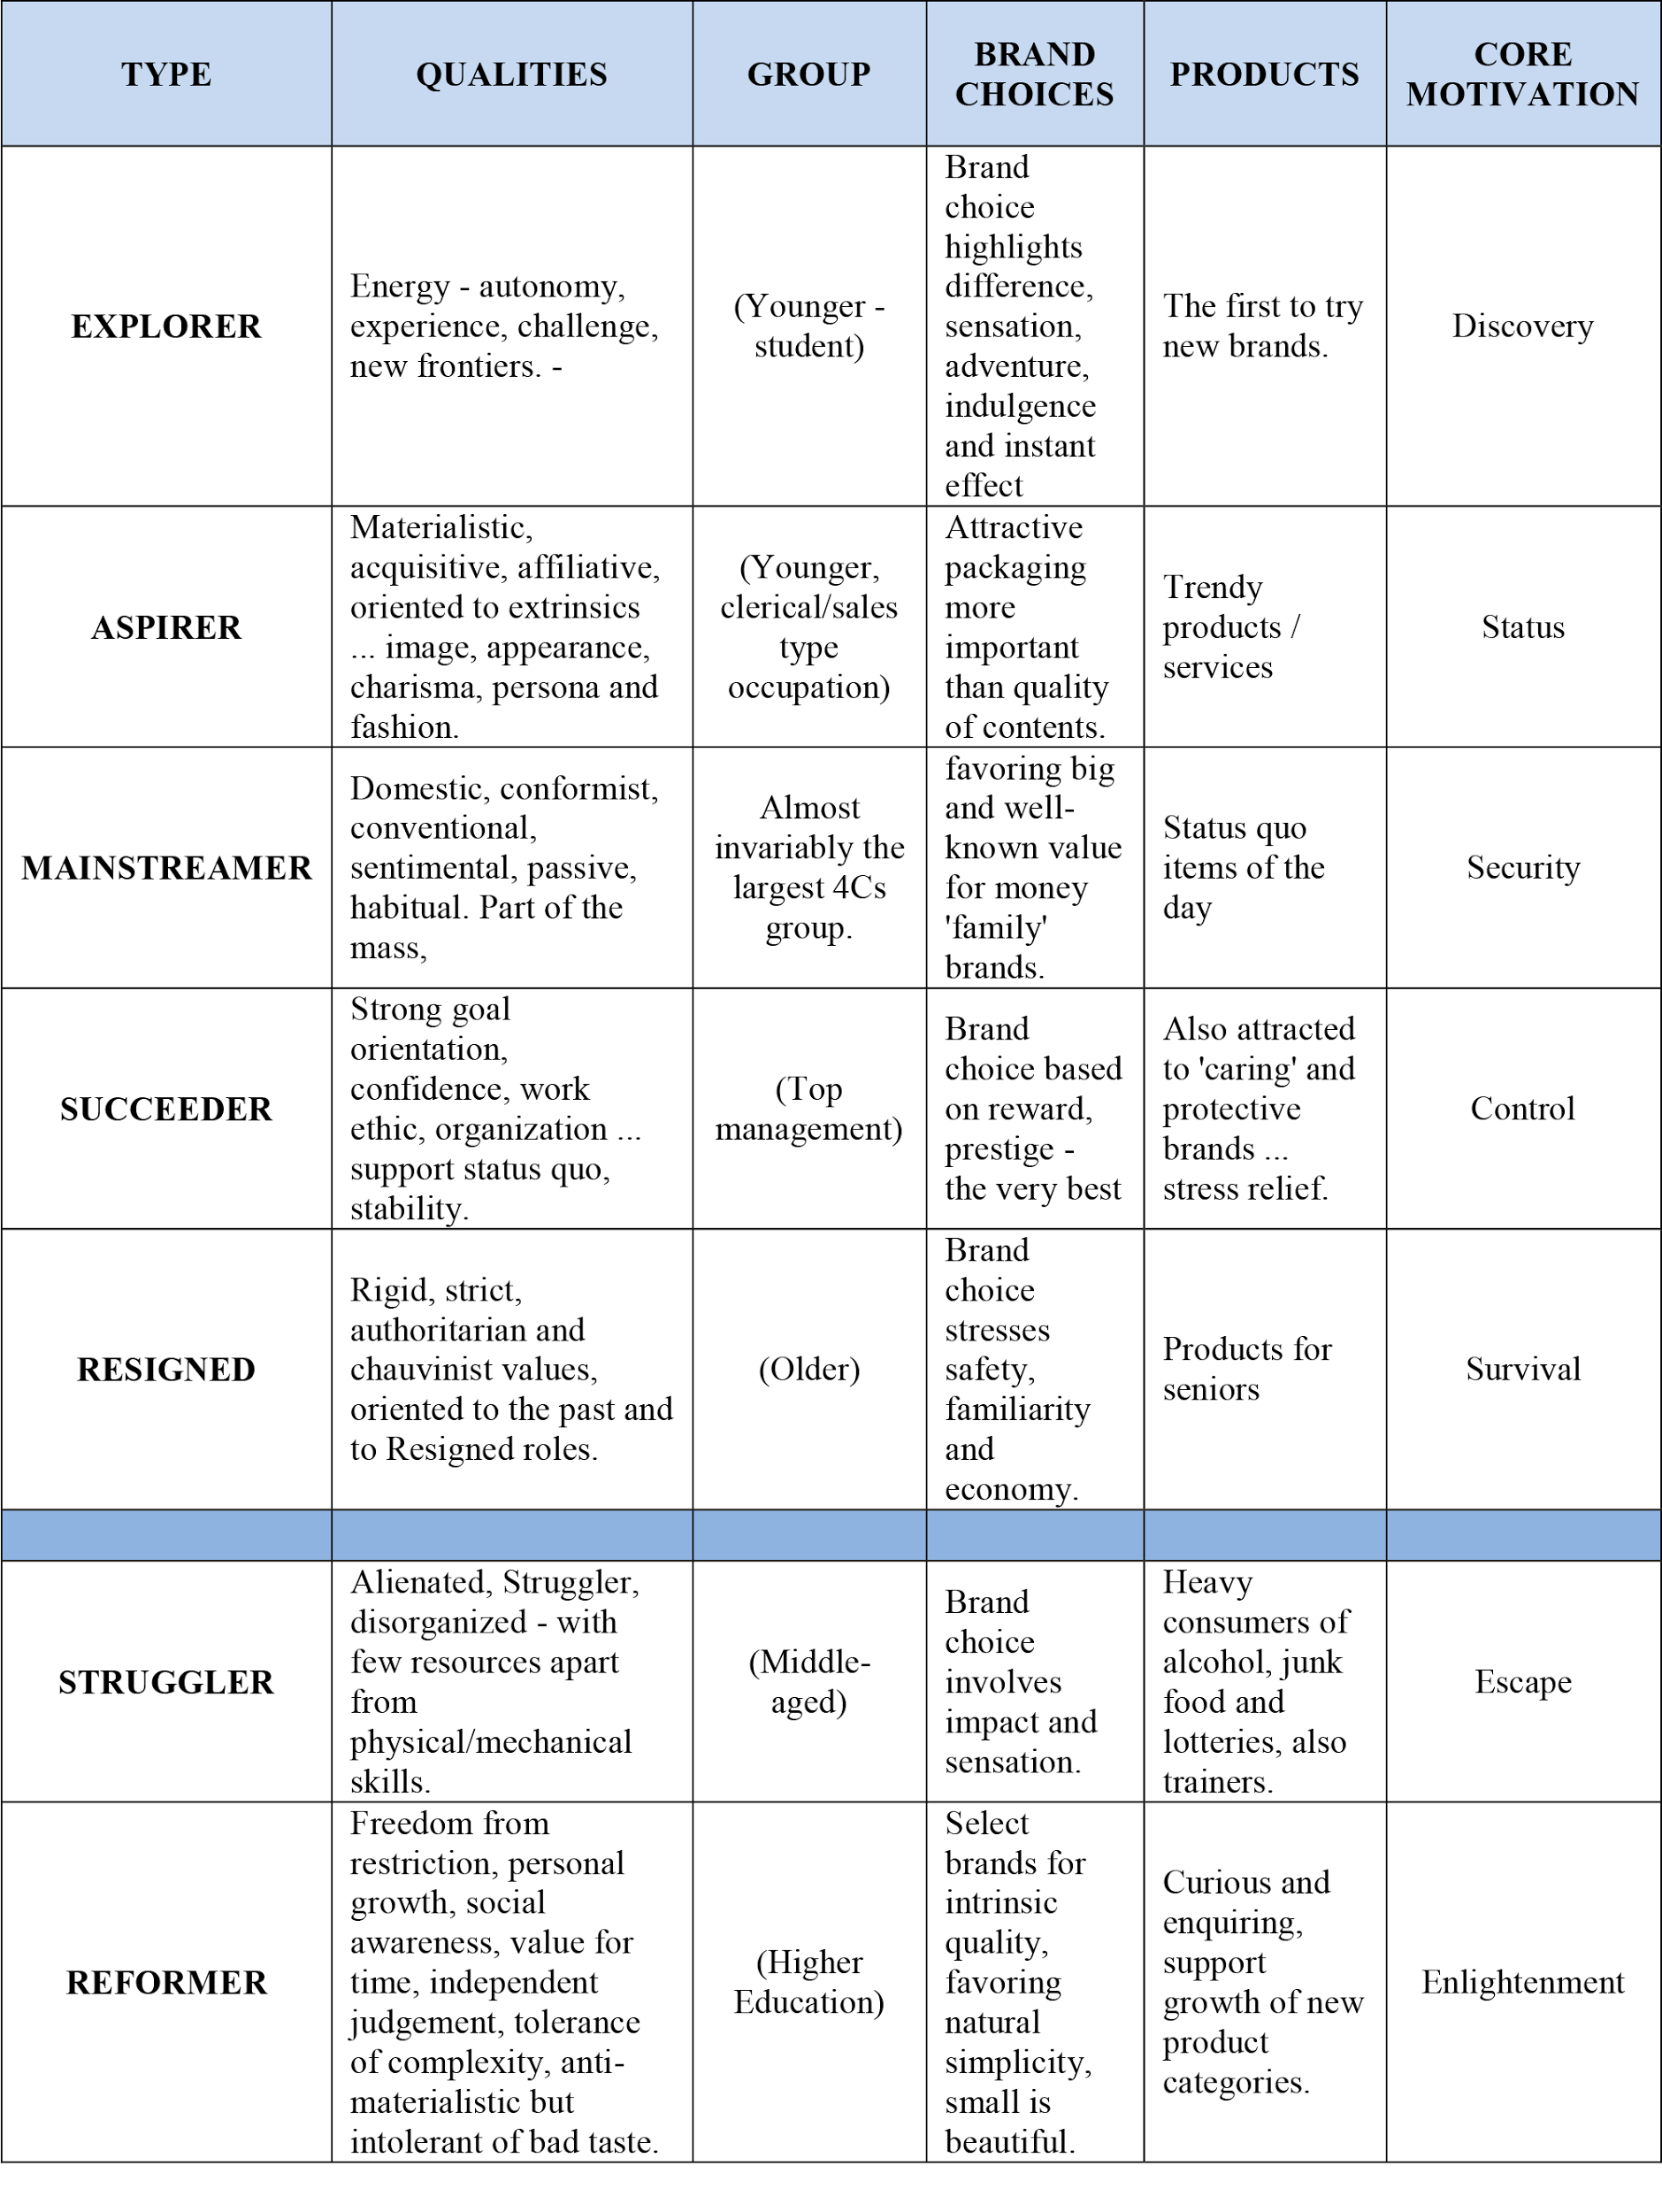

Bartle test: Explorer

### How their requirements will be meet

An indie title with trial and error gameplay. A genre that lends itself to exploration and discovery. The humour and themes of the story will be tailored millennials in western culture.

## Genre

Gameplay genre: Point and click game with first person shooter, controls and camera model.

Story genre: dark comedy fantasy

## UNIQUE SELLING POINTS

Point and click games aren’t in popularity like they were in the 90s. So the market is open for new point and click games with a style of game play. We are mixing the controls of a first person game with the point and click genre.

## Target platform

PC game, as we won’t be able to get a licence to publish our game on console platforms

## VISUAL STYLE

Over the top cartoon style which doesn’t present reality at all. Objectives won’t be restricted to in real sizes and will be exaggerated.

# Story

## Synopsis of story

Jerry a nerdy demon who has been working an office jobs for a thousand years is called to his boss’s office. The boss wants to get out of hell and the only way to get out is to have a pure soul. So the boss blackmails Jerry for get it for him. So now Jerry must find a way to obtain this pure soul. First jerry need to find out how. Jerry finds out Jim knows something about souls. So Jerry needs to escape the office.

Once he is free from the office he will meet Jim who will tell him about the souls. Jerry will also meet Franki at the bar who will help you get into new location to help you.

Harriet will me stalking Jerry and help him to stand up against the boss and want the soul for himself.

Once he has taken the soul he will discover it was all for nothing but he can live happy will Harriet

## Plot

Boss has blackmailed the nerdy demon to steal him a pure soul.

## Theme

Cooperation over individual, gaining self-identity, overcoming weakness, religion, meta narrative

## Conflict

Finding a way to steal the soul without being found.

## SETTING

Set in a hell that isn’t so much of torture and lake of firs but more of capitalist society where people who are weak in hell are doomed to an office job for the rest of their eternity. Everyone knows heaven is a better place to live but unless you have a pure soul you won’t be able to escape this living hell. In this hell there are motels, museums’, torture shops, gift shops, bars and Satan’s pimp house.

## Characters

### Jerry

**Goal**: To avoid punishment he must find a way to get a soul for his boss

**Weakness**: Gullible, no power or skills he is outmatched. He does what he is told to do.

**Description:** A demon who has been working in this office for thousands of years. He had no potential for his creation as he was doomed to an office job. He is small and nerdy for a demon.

**Story arc:** Jerry will grow more and more confident throughout this adventure to the point there he is no longer thinking about his bosses needs but his own. At the start he has to get the soul for his boss but he later plans to get the soul for his own.

### Boss

**Goal:** To get ‘the hell out of’ Hell. With as little effort as possible. He has been working here to too long and wants to rise to the top. Up in heaven where he can have a better life.

**Weakness:** Doesn’t give a damn. In it for his own interests. Hates working at anything.

**Description:** Being drinking mates with Satan back in the torture business days. He was able to get a good job for himself as Boss. Sadly for him the torture business has been taken over by the rise of corporate business. This massive demon wants out.

**Story arc:** A lazy boss who wants out, sends his dumpiest and gullible employee who would never double-cross to get him the soul. The boss to his surprise gets double-crossed by Jerry and wants revenge.

### Other characters

* **Skeleton Gary** (skull that sits next to jerry and teases him all the time)
* **Lil Barry the gnome** (in cage, super hyper and needs to be contained)
* **Lonesome Larry** (Skeleton, sits in corner, is very short and blunt with people)
* **Terrible Terry** (Skeleton, terrible at the job but gets away with it) “Hey Jerry, can you do some write ups for me later?” “What am I even doing here?” “How do I turn my screen on again?” “I think my mouse ran off again.”
* **Lary Mary** (Skeleton, mean office lady skeleton)
* **Catherine** (Skeleton, try hard)
* **Anne-marie** (Skeleton, gossiper)
* **Rod** (Skeleton, likes to cause conflict between others for his own amusement)
* **Harry** (Male skeleton)
* **Filthy Franki -** A flirtatious skeleton who knows a lot more than she lets on. He can get Jerry escaping the office and how to get into Satan’s pimp house.
* **Jim** – An undercover skeleton in the office who wants to bring Satan down. He can tell you where the souls are kept and a blueprint of the pimp house. He also knows people who can help you out on this heist.
* **Harriet** - A female skeleton that has an obvious crush on Jerry, Jerry is too naive to notice. Harriet stalks Jerry for most of the game. Harriet is key into getting Jerry to become confident and double-cross his boss to get the souls for himself.

# Game play

## core experience

### What is the intended user experience and emotional objective?

Trial and error is the intended experience for the player. The player will experience frustration for the puzzles they can’t solve and resolution for when they solve it. The objectives have mini stories of their own so there will be an emotional engagement for the objectives the player has to complete. As well as an emotional engagement to the heist the player will be working towards.

### What is the core experience?

At its core ‘Corporate hell’ is about preparing yourself for the heist. All the objectives you do for others and the tools you collect is all in the effort in learning more about where and how you will steal this pure soul. Preparing through trial and error learning the skills and gaining the tools to complete the game.

### What are the game play mechanics?

The player will make the basic control of a first person game, walking, jumping and moving camera. The player will be able to interact with intractable objects, like throw a sausages. Use a crowbar break a cage. Collect keys which open doors. Use gargets with their special ability.

### What is the progression?

To progress through this game you must complete objectives which gain access to new areas. These new areas will help aim the player in the heist of the soul.

## Goal

The goal is to get a pure soul for your boss. To complete this goal get knowledge, skills and tools to help you get the pure soul. You will gain these through completing objective given to you by characters in the game world.

## Challenge

The challenges is work out how to complete the objectives given to you. You have to use trial and error in order to finally reach a solution to the objective.

## Feedback

Characters will give you information and feedback throughout the objectives you are doing for them. They will say a key word or goal that will point you to the right direction. For example a lary Mary will ask for coffee. So the player will look out for something coffee related. They will find the coffee machine and on this machine there is a note that says ‘We need coffee beans Larry!’ This will guide you to Larry.

So the game gives you feedback in ‘breadcrumbs’ that points you to where you need to me next.

## Reward

When the player has completed an objective that objective will point you in the right direction to how you will steal this pure soul. You will be rewarded will knowledge of how to get the soul, skills how to steal the soul, and tool to help get the soul. All reward are to advance the player to the end goal.

### Mechanics

Avatar based interaction model with a first person camera model.

-Walk, jump and free camera movement

- Interaction with game objects. There are three types:

Quest items like a donut’s only purpose is to be given to Gary.

Tools like a crowbar which can be used to destroy objects.

Gadgets which will be used for the heist which will make their unique ability.

-Dialogue: A limited Input and response. Player choose from a selection of lines and the NPC response to that line.

- Inventory: When player presses the inventory key, in game the player will see the models of the objects they have on them and can scroll through them to choose the object them want to handle.

## GAME Theory

Cascading Information Theory: Information of the game world and the narrative is release in snippets throughout the game. The player progresses through finding more information to get to the next amount of information. The player doesn’t know the complete story until the end of the game.

Urgent Optimism: I want the play to make the play have the self-motivation and desire to try and tackle obstacles with the hope of success.

Discovery: This is exploration side of my game. The player will feel rewarded to finding hidden information and stories placed into the game world. Discovery engages the player to look deeper and find our little details and Easter eggs we have placed into the game world.

## Rules in the game

The rules of the game world are:

1 There is no fail state. The player can’t die

2. There is no combat within the game

3. The player can escape our game world boarders

4. The player can’t finish the game without completing the tasks we set out for them.

## subtractive design

The main aim for this game is to minimise all the content to focus on the main purpose and theme. The purpose of the game is to make a survival horror with themes of nihilism: insignificances and a godless world. I have made sure that anything that doesn’t connect to the purpose or theme then I will cut it from the game. The focus is set on making the experience and story suited to nihilism themes: meaning that the mechanics and levels show different aspects of the theme: weakness, insignificant, meaningless existence, humility and the cosmos.

## Flow Channel

I will design the puzzles in this point and click to first teach the player, and get them a safe environment to test, and challenge them on what I have taught them. I want each new mechanic to be taught in this three step fashion. So the player’s skill will be level with the challenges I give them.

## semiotics

Semiotics will be used for the crosshair. The crosshair will change when it moves over something important. The crosshair might change into a hand symbol to indicate you can pick up this object.

## Colour Scheme

I will let Rob create this…

# Chapters

## Office

**Description:** A 90s office set in hell. Someone is either a skeleton or a demon (Or a gnome). Nothing is cleaned or tidy. People do want they want but are prisoned here for eternity.

**Purpose:** A safe environment to learn the mechanics and the basic lore and plot of this story.

**Theme:** Hell is an office, worker bee’s under a rich lazy boss, capitalism in the underworld.

**Objective structure:** 1) Boss’ Office. 2) Gary wants donuts. 3) Terry wants his arm back. 4) Get lary Mary her coffee and get rid of Anne for Lonesome Larry. 5) Help Rod release Lil Barry and escape the office.

**Tools**: The crowbar and scissors

**Colour scheme**: Office colours which you see a lot of employs wearing.



**Level layout:**

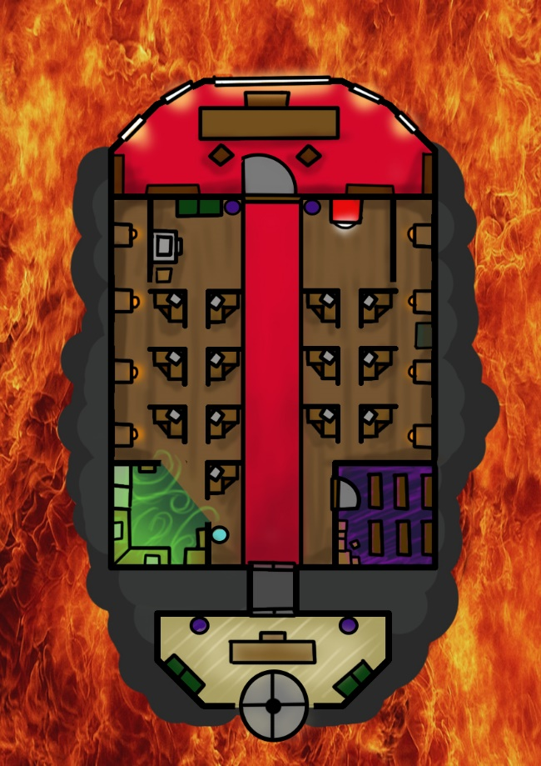

## Hub world

**Description:**

**Purpose:**

**Theme:**

**Objective structure:**

**Tools**:

**Colour scheme**:

**Level layout:**

## Salon

**Description:**

**Purpose:**

**Theme:**

**Objective structure:**

**Tools**:

**Colour scheme**:

**Level layout:**

## Gift shop

**Description:**

**Purpose:**

**Theme:**

**Objective structure:**

**Tools**:

**Colour scheme**:

**Level layout:**

## Motel

**Description:**

**Purpose:**

**Theme:**

**Objective structure:**

**Tools**:

**Colour scheme**:

**Level layout:**

# User Interface

Need to add

# Audio

## Soundtrack

### Music references:

Sam & Max Save the World ost by Jared Emerson-Johnson

Beetlejuice ost by Danny Elfman

### Soundtrack List

Track 1: Example track

**Description**: Catchy beats. Has a jazz vide

**Where:** In the hub world

**Time (in minutes): 2 minutes**

**Instrument**: Drums and horns

**Emotional impact**: The player is ready for an adventure